Successful TIIS certification
Japanese approval for intrinsically safe EE300Ex humidity and temperature transmitter

(Engerwitzdorf, 13.10.2016) The intrinsically safe EE300Ex humidity and temperature transmitter from E+E Elektronik has been certified according to TIIS. The device, which already meets the relevant requirements for Europe and North America (ATEX, IECEx, FM), may now be employed in Japan as well. TIIS-certified EE300Ex devices can be obtained from the Japanese E+E sales partner TEKHNE Trading Co., Ltd.

EE300Ex is dedicated for use in potentially explosive environments and can be installed directly in both gas and dust hazardous areas of zone 0 / 20. The device accurately measures relative humidity and temperature in the range from 0 to 100% RH and -40 to 180°C (-40...356 °F) with pressure rating up to 300 bar (4351 psi). The EE300Ex is also available for moisture measurement in oil as well as for temperature measurement only.

The EE300Ex is very easy to install due to the separation of the measurement unit and the connecting area. The two-part enclosure allows the measurement unit to be removed for maintenance or calibration, while the connecting area remains in place with intact wiring.

The EE300Ex is available as wall mount or with a remote sensing probe with up to 10 m probe cable length. The measured values are shown on the optional display. The enclosure and the probe of high-quality stainless steel are suitable even for harsh industrial conditions. The proprietary E+E coating protects the sensors from contamination and corrosion, which leads to outstanding long-term stability.

The measured values are issued on two 4…20 mA outputs. In addition to the measured relative humidity and temperature, the EE300Ex calculates other physical quantities such as dew point or frost point temperature, absolute humidity and mixing ratio. Individual configuration of the transmitter and adjustment of the analogue outputs can be easily performed with the free configuration software.

Further information about the EE300Ex are available at www.intrinsically-safe-measurement.com

Characters (no spaces): 1793
Words: 319
Images
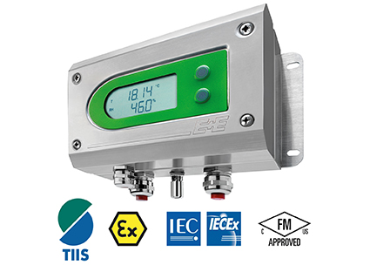 | Figure:  TIIS-certified: the EE300Ex humidity and temperature transmitter.

Photos: E+E Elektronik GmbH, reprint free of charge

About E+E Elektronik:
E+E Elektronik develops and manufactures sensors and transmitters for humidity, temperature, dewpoint, moisture in oil, air velocity, flow and CO₂. Data loggers, hand-held measuring devices and calibration systems complete the comprehensive product portfolio of the Austrian sensor specialist. The main applications for E+E products lie in HVAC, building automation, industrial process control and the automotive industry. A certified quality management system according to ISO 9001 and ISO/TS 16949 ensures the highest quality standards. E+E Elektronik has a worldwide dealership network and representative offices in Germany, France, Italy, Korea, China and the United States. The accredited E+E calibration laboratory (OEKD) has been commissioned by the Austrian Federal Office for Metrology (BEV) to provide the national standards for humidity and air velocity.

Contact: www.epluse.com, info@epluse.at, T: +43 (0) 7235 605-0, F: +43 (0) 7235 605-8

For further inquiries: Mr. Johannes Fraundorfer, T: +43 (0)7235 605-217, pr@epluse.at

