Press Release

# Calculator for Physical Humidity Quantities and Pressure Dew Point

The new Humidity Calculator by E+E Elektronik computes all relevant humidity-related parameters as well as the pressure dew point.

(Engerwitzdorf, 3.8.2022) **With the Humidity Calculator by E+E Elektronik, complex humidity calculations can be performed easily and in real-time. This free calculation tool works online in any recent browser and can also be installed as an app on smartphones or a PC. Up to 15 humidity-related parameters can be computed with the practical calculation program. In addition, the E+E Humidity Calculator features a separate calculation mode for determining the pressure dew point.**

## Humidity calculation including measurement uncertainty

Based on three known physical quantities (pressure, temperature, and a humidity measurand), the E+E Humidity Calculator computes up to 15 humidity-related parameters such as the dew point, frost point, absolute humidity, enthalpy, etc. A significant difference to other humidity calculators is that the E+E Humidity Calculator also takes the measurement uncertainty into account and therefore ensures particularly practical results.

In addition to computing and converting physical humidity quantities, the E+E Humidity Calculator can also be used to simulate the behaviour of the humidity values as pressure and temperature conditions change. For realistic calculations, air and 10 other gases (including argon, CO2, helium, and methane) can be selected as the carrier medium.

The formulae for conversion, including computing the uncertainty, are based on the common humidity theories and have been validated by the accredited E+E Elektronik calibration laboratory.

## Practical dew point calculator

In addition to calculating the humidity, the E+E Humidity Calculator features a separate calculation mode for computing the dew point in compressed air systems. This makes it easy to determine the change in dew point temperature in relation to the gas pressure.

## User-friendly and functional

The E+E Humidity Calculator is easy and intuitive in use, and it offers a rich set of useful features. For example, the measurement units of the physical quantities can be converted from SI to the US system of units with just one click, or individually defined for each physical quantity. Users can adapt the list of calculated physical quantities to suit their own needs by displaying or hiding individual lines. The computation results can be exported as PDF or Excel files and also sent via e-mail. A click on the Reset button clears all calculations and restores the initial list of measurands.

The E+E Humidity Calculator is accessible on **humidity-calculator.epluse.com**.

Characters (incl. spaces): 2296  
Words: 401

### Images

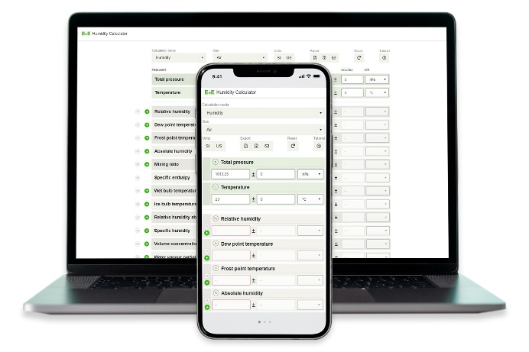

The E+E Humidity Calculator calculates all relevant humidity related physical quantities and also the pressure dew point.

Photos: E+E Elektronik Ges.m.b.H., reprinting free of charge

### Company profile

E+E Elektronik develops and produces sensing elements, modules and sensors for humidity, dew point, moisture in oil, CO2, air velocity, flow, temperature and pressure. Hand-held meters, humidity calibration systems and calibration services complete the comprehensive product portfolio of the Austrian sensor specialist. The main applications for E+E products lie in HVAC, building automation, industrial process control and the automotive industry. A certified quality management system according to ISO 9001 and IATF 16949 ensures the highest quality standards. E+E Elektronik is represented by its own subsidiaries in China, France, Germany, India, Italy, Korea, USA and by sales partners in more than 60 countries worldwide. The accredited E+E calibration laboratory has been commissioned by the Austrian Federal Office of Metrology and Surveying (BEV) to provide the national standards for humidity, dew point, air velocity and gas concentration CO2.

**E+E Elektronik Ges.m.b.H.**Langwiesen 7  
4209 Engerwitzdorf  
Austria  
T +43 7235 605-0  
[info@epluse.com](mailto:info@epluse.com)  
[**www.epluse.com**](http://www.epluse.com)

**Press contact**Mr. Johannes Fraundorfer  
T +43 7235 605-217  
[pr@epluse.com](mailto:pr@epluse.at)