Press Release

**High-End Humidity and Temperature Sensor for Highest Demands**

The HTS801 sensor supports highly accurate measurement of humidity and temperature even under the most challenging conditions such as high humidity and chemical exposure.

(Engerwitzdorf, 14.09.2023) **The new HTS801 sees E+E Elektronik launch its most powerful humidity and temperature sensor for industrial applications on the market.** **This versatile, high-end measuring device combines the Austrian sensor specialist's decades of experience in the field of humidity measurement with the high quality demands of industrial metrology. The sensing probes of the HTS801 incorporate a premium, heatable sensing element for accurate measurements, guaranteeing long-term stability even under the most challenging conditions. Additional options such as a large colour display or plug-and-play probe replacement using rapidX technology ensure user-friendly operation and easy maintenance.**

**Excellent Measuring Performance, Wide Range of Applications**

The HTS801 is particularly well suited to use in applications with high humidity and chemical exposure. It is based on the E+E sensing element with monolithic structure. An integrated heater enables targeted heating of the sensing element to prevent condensation and its negative impacts on the measurement results. Depending on the requirements, two type-specific operating modes are available for selection:

* "Condensation Guard" in case of a short-term risk of condensation
* "High Humidity Guard" for permanent exposure to high humidity and condensing conditions

In addition to this, all HTS801 models have an Automatic ReCovery (ARC) function. ARC removes chemical impurities and eliminates possible drift effects through short-term intensive heating of the sensing element.

Furthermore, the tried and trusted E+E sensor coating protects the sensing element and its leads against corrosion or deposits. This special coating extends the sensor's service life, ensuring accurate measurement results and improved long-term stability in harsh or corrosive environments.

Thanks to its wide operating range from -80 °C to 180 °C (-112 °F to 356 °F) and 300 bar (4 351 psi), the HTS801 is suitable for a variety of applications; for example, for monitoring drying processes, humidity and temperature monitoring in fuel cell test benches, climate chambers or high-humidity storage rooms to demanding measurement tasks in meteorology and much more.

The rugged polycarbonate or stainless-steel enclosure, featuring IP65 / NEMA 4X protection, supports easy mounting and maintenance of the HTS801.

**Plug-and-Play Probe Exchange**

The HTS801 offers the option of smart, pluggable sensing probes. Every HTS801 rapidX smart probe can be exchanged without configuration, adjustment or calibration following the plug-and-play principle. The specific parameters are stored directly in the probe and are transmitted to the sensor when the probe is plugged in. This avoids downtime and costs if a probe needs to be replaced due to damage or for recalibration.

**Display with Data Logging and Diagnostics Function**

The HTS801 is optionally available with a 3.5" TFT colour display. This allows up to four physical quantities to be displayed simultaneously and monitored locally. The integrated data logging function stores up to 20 000 measured values per measurand. The values can be visualised on the display or downloaded using the USB service interface. Thanks to the on-board diagnostics function, the operating status of the HTS801 can be checked directly on the device.

**Interfaces and Configuration**

The measured data is available at two freely scalable analogue outputs, RS485 (Modbus RTU) or Ethernet PoE (Modbus TCP) interface, and at two alarm (relay) outputs. This enables flexible integration of the sensor into customer's own data acquisition systems.

The HTS801 can be configured via the USB port using the free PCS10 configuration software or directly on the device using the display and push-buttons.

Characters (incl. spaces): 3984  
Words: 585

### Images

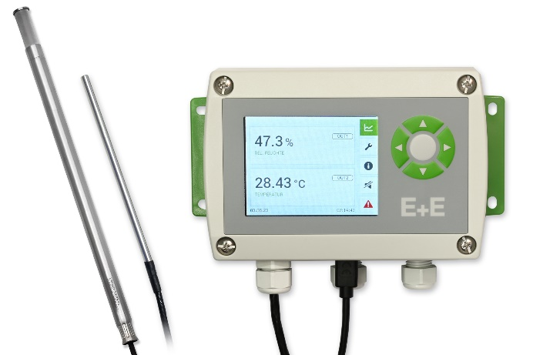

HTS801 humidity and temperature sensor for demanding industrial applications.

Ein Bild, das Elektronik, medizinische Ausrüstung, Elektronisches Gerät, Messgerät enthält.

HTS801 humidity and temperature sensor with stainless steel enclosure.

Photos: E+E Elektronik Ges.m.b.H., reprinting free of charge

### Company profile

E+E Elektronik develops and produces sensing elements, modules and sensors for air velocity, CO2, dew point, flow, humidity, moisture in oil, pressure and temperature. Hand-held meters, humidity calibration systems and calibration services complete the comprehensive product portfolio of the Austrian sensor specialist. The main applications for E+E products lie in industrial process control as well as HVAC and building automation. A certified quality management system according to ISO 9001 and IATF 16949 ensures the highest quality standards. E+E Elektronik is represented by its own subsidiaries in China, France, Germany, India, Italy, Korea, USA and by sales partners in more than 60 countries worldwide. The accredited E+E calibration laboratory has been commissioned by the Austrian Federal Office of Metrology and Surveying (BEV) to provide the national standards for humidity, dew point, air velocity and gas concentration CO2.

**E+E Elektronik Ges.m.b.H.**Langwiesen 7  
4209 Engerwitzdorf  
Austria  
T +43 7235 605-0  
[info@epluse.com](mailto:info@epluse.com)  
[**www.epluse.com**](http://www.epluse.com)

**Press contact**Mr. Johannes Fraundorfer  
T +43 7235 605-217  
[pr@epluse.com](mailto:pr@epluse.at)