Press Release

**New Room Sensor Generation by   
E+E Elektronik**

The new CDS201, HTS201 and TES201 room sensors enable accurate and reliable CO2, humidity and temperature measurements in residential and commercial buildings.

(Engerwitzdorf, 08 November 2023) **A trio consisting of the CDS201, HTS201 and TES201 sees Austrian sensor specialist E+E Elektronik launch a new generation of accurate and reliable room sensors. Tailored to the respective facility automation application, the CDS201 3-in-1 device for CO2, humidity and temperature, the HTS201 humidity and temperature sensor and the TES201 temperature sensor are great choices. Each variant has analogue outputs or a digital interface and a large, state-of-the-art display. The functional snap-on enclosure minimises installation costs and avoids the intake of false air.**

**Excellent Measurement Performance, Innovative Design**

## The three sensors impress with their outstanding accuracy in terms of the physical quantities. This results from E+E Elektronik's many years of experience in the production of high-quality sensing elements.

## On top of this, the elegant, functional snap-on enclosure design is exciting and available in two sizes (EU and US versions) depending on regional standards. The lower part of the housing only contains the plug-in terminals and can be installed and connected without the cover, which contains the electronics. This means that the active part of the device is not exposed to any contamination and can be fitted on the lower part shortly before commissioning. The innovative enclosure also prevents the ingress of false air and significantly reduces self-heating. The sensors are optionally available with a state-of-the-art, easy-to-read graphic display.

## Interfaces and Configuration

The measured values are either delivered via analogue outputs or to the digital interface using the Modbus RTU or BACnet MS/TP protocol. The digital version with its RS845 interface can be set up and configured on a PC using the free PCS10 product configuration software and an optional configuration adapter.

**Areas of Application**

The new room sensors are highly suited for use in demand-driven ventilation, heating and air conditioning technology, and facility automation.

**CDS201 – The Versatile Choice**

The CDS201 combines CO2, temperature (T) and relative humidity (RH) measurement in a single device and is particularly well suited for demand-driven ventilation and facility automation in residential and commercial applications.

The CDS201's CO2 measurement relies on the contamination-resistant NDIR dual wavelength principle. This technology automatically compensates for aging effects, while at the same time guaranteeing excellent long-term stability. Factory multi-point CO2 and temperature adjustment ensures high measurement accuracy over the entire temperature operating range.

E+E sensor coating protects the active RH/T sensing element against contamination and corrosive deposits. This results in improved measurement performance and longer sensing element life in environments with high levels of dust or soiling exposure. In addition, it improves long-term stability by preventing stray impedances caused by deposits on the active sensor surface.

**HTS201 – The Allrounder**

The HTS201 is designed for accurate and reliable measurement of relative humidity (RH) and temperature (T) in residential and commercial facility automation applications.

The E+E RH/T sensing element with its patented sensing technology guarantees excellent performance over the entire operating range even in environments with high levels of dust or soiling exposure. Again, E+E sensor coating ensures long-term stability for the measurements.

**TES201 – The Efficient Choice**

The TES201 is designed for accurate room temperature measurement (T) for indoor climate control. In addition to proven, high-quality E+E sensing technology, these room sensors impress with their great price/performance ratio.

Characters (incl. spaces): 5.292  
Words: 749

### Image

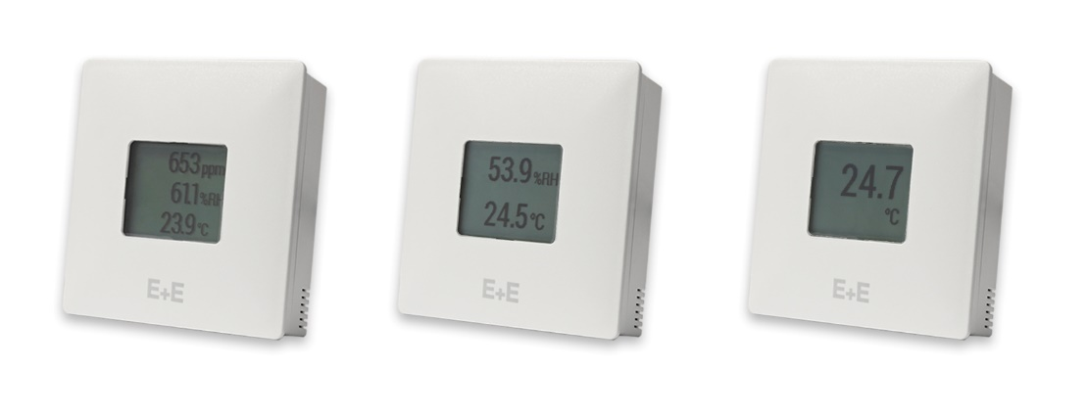

The new E+E room sensor generation: CDS201, HTS201, TES201 (from left to right)

Photos: E+E Elektronik Ges.m.b.H., reprinting free of charge

### Company profile

E+E Elektronik develops and produces sensing elements, sensing modules and sensors for CO2, pressure, flow, humidity, moisture in oil, air velocity, dew point and temperature. Handheld measuring devices, humidity calibration systems and calibration services round off the Austrian sensor specialist's extensive product portfolio. The main areas of application for E+E products are in industrial measurement technology, HVAC and facility engineering. A certified quality management system according to ISO 9001 and IATF 16949 ensures the highest quality standards. E+E Elektronik is represented by its own subsidiaries in China, Germany, France, India, Italy, Korea, and the USA, and by sales partners in more than 60 countries worldwide. The accredited E+E calibration laboratory has been tasked by Austria's Federal Office of Metrology and Surveying (BEV) with providing the national standards for humidity, dew point, air flow velocity and CO2 gas concentration.

**E+E Elektronik Ges.m.b.H.**Langwiesen 7  
4209 Engerwitzdorf  
Austria  
T +43 7235 605-0  
[info@epluse.com](mailto:info@epluse.com)  
[**www.epluse.com**](http://www.epluse.com)

**Press contact**Mrs. Eva Schönhart  
T +43 7235 605-479  
[pr@epluse.com](mailto:pr@epluse.at)