Press information

# New Management at E+E Elektronik

New impulses at the Upper Austrian sensor specialist E+E Elektronik.

(Engerwitzdorf, July 23, 2024) **Since July 1, 2024, the new management of the Engerwitzdorf-based sensor manufacturer E+E Elektronik is complete. Wolfgang Pucher has taken up his position as Technical Managing Director. Min Kim already took over responsibility for the Market Division in May 2024. This new set-up strengthens the company's management and provides new impulse for future development.**

## New Managing Director Market Division: Min Kim

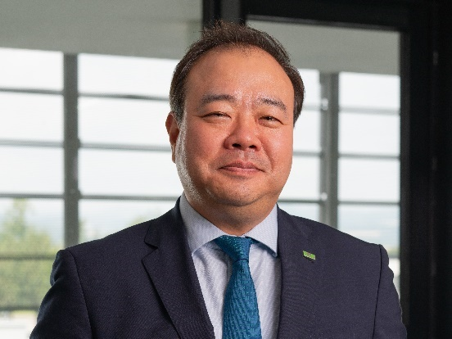Min Kim has over 23 years of professional experience, including 15 years in various international management positions. The 52-year-old studied economics and business administration in Germany and built up his initial expertise in particular at the Robert Bosch Group in Asia-Pacific regions. His portfolio also ranges from global sales management to the integration of acquired companies. Since May 1, 2024, Mr. Kim has been responsible for the Market Division at E+E Elektronik. In this role, he is responsible for sales and marketing, product management, purchasing and logistics, human resources and all seven subsidiaries.

Min Kim

## 

## New Managing Director Technology Division: Wolfgang Pucher

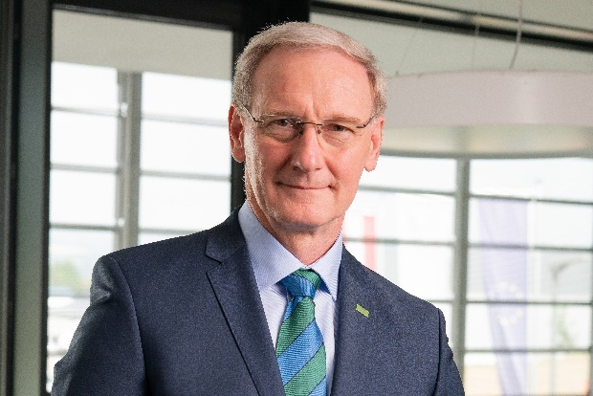Wolfgang Pucher took over the management of the Technology Division at E+E Elektronik on July 1, 2024. His area of responsibility includes development, production, quality management, calibration laboratory, IT and technical infrastructure. Wolfgang Pucher studied mechanical engineering and completed his doctorate in measurement technology at the Technical University of Graz. In 1997, the 61-year-old joined Dr. Johannes Heidenhain GmbH, where he held numerous management positions in the development of measuring devices and precision machines. As Head of Development, he has many years of experience in development, production, assembly, quality management and marketing.

Wolfgang Pucher

## Strong expertise for future development

## With Min Kim and Wolfgang Pucher, two highly experienced managers have been recruited. Their expertise in their respective fields will contribute to developing E+E Elektronik from a recognized, solid company to an innovative global market leader with pioneering technology. Together, new market opportunities will be developed, and the customer base is to be expanded. In addition, the optimization of development and production processes and the promotion of innovative solutions are on the agenda.

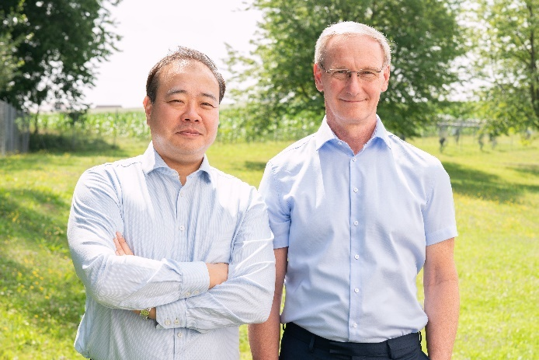

The new managing directors of E+E Elektronik: Min Kim, Wolfgang Pucher (from left to right)

Photos: E+E Elektronik Ges.m.b.H., Reprint free of charge

### Company profile

E+E Elektronik develops and produces sensor elements, sensor modules and sensors for CO2, pressure, flow, humidity, moisture in oil, air velocity, dew point and temperature. Hand-held meters, humidity calibration systems and calibration services complete the extensive product portfolio of the Austrian sensor specialist. The main areas of application for E+E products are in industrial measurement technology as well as HVAC and building technology. A certified quality management system in accordance with ISO 9001 and IATF 16949 ensures the highest quality standards. E+E Elektronik is represented by its own subsidiaries in China, Germany, France, India, Italy, Korea, USA and sales partners in more than 60 countries worldwide. The accredited E+E calibration laboratory is commissioned by the Austrian Federal Office of Metrology and Surveying (BEV) to provide the national standards for humidity, dew point, air flow velocity and gas concentration CO2.

**E+E Elektronik Ges.m.b.H.**Langwiesen 7  
4209 Engerwitzdorf  
Austria  
T +43 7235 605-0  
[info@epluse.com](mailto:info@epluse.com)  
[**www.epluse.com**](http://www.epluse.com)

**Press contact**Mrs. Eva Schönhart  
T +43 7235 605-479  
[pr@epluse.com](mailto:pr@epluse.at)